Figma - Class Activity – 03.10.2026
1. Online Food Delivery App – Mobile UI Design
Scenario:
A food delivery company wants a mobile application through which customers can browse
restaurants, search for food, add items to a cart, and place orders.
Question:
Using Figma, design a mobile food delivery application with the following screens:
1. Login Screen – Email, password, Login button, and Forgot Password option.
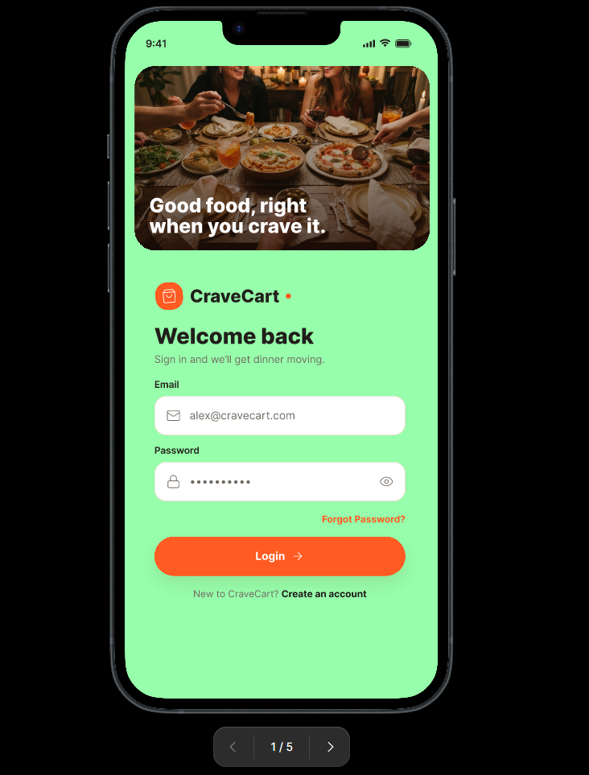
2. Home Screen – Search bar, food categories, restaurant cards, and navigation bar.
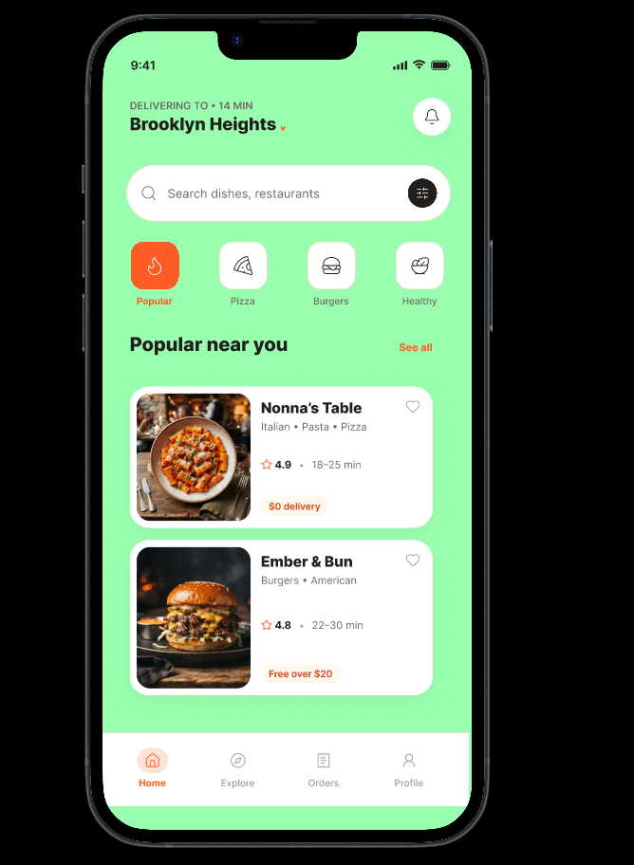

3. Restaurant Menu Screen – Restaurant name, food items, prices, images, and Add button.
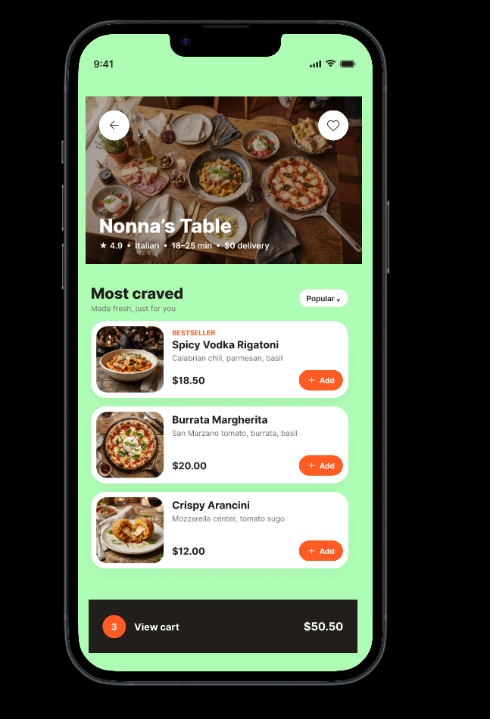

4. Cart Screen – Selected items, quantity, total amount, and Checkout button.
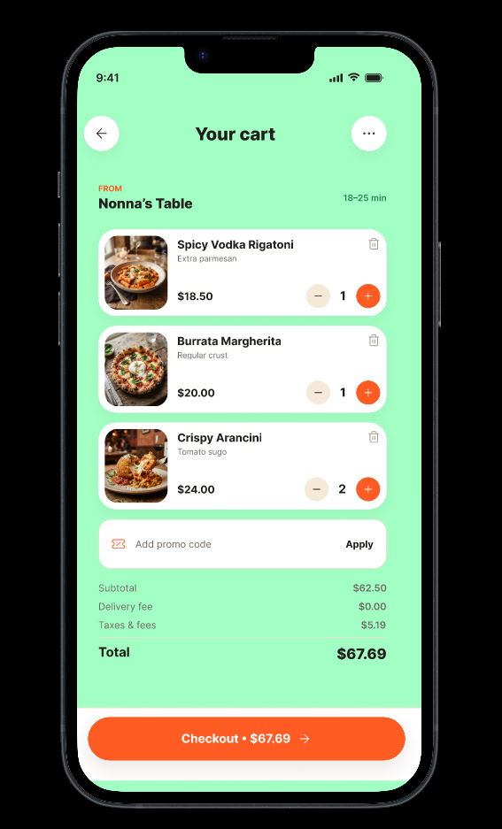

5. Order Confirmation Screen – Order number, total amount, delivery status, and
estimated delivery time.
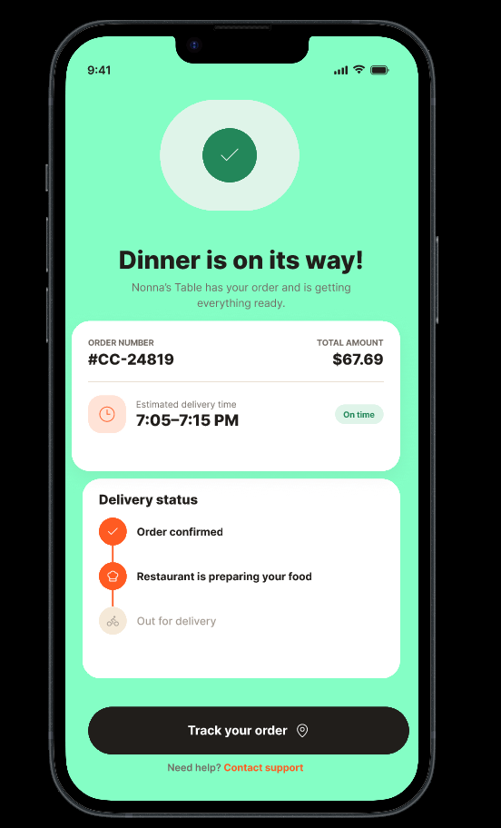
Figma requirements: Use Frames, Auto Layout, Components, icons, and Prototype interactions to connect the screens.

2. College Student Attendance App – UI/UX Design
Scenario:
A college wants a mobile application that allows students to view their attendance percentage
and attendance details for different subjects.
Question:
Using Figma, design a student attendance application containing:
1. Login Screen – Student ID, password, and Login button.
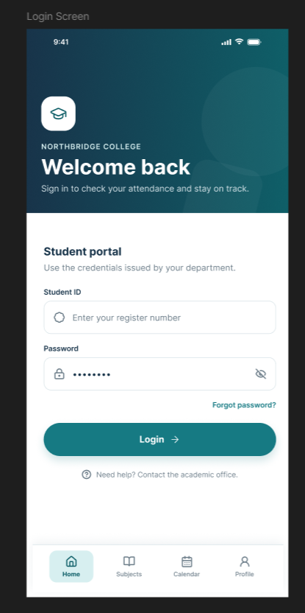

2. Dashboard – Student name, register number, overall attendance percentage, and
subject summary.

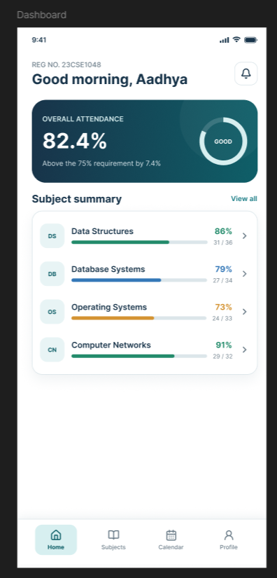

3. Subject Details Screen – Subject name, classes conducted, classes attended, and
attendance percentage.
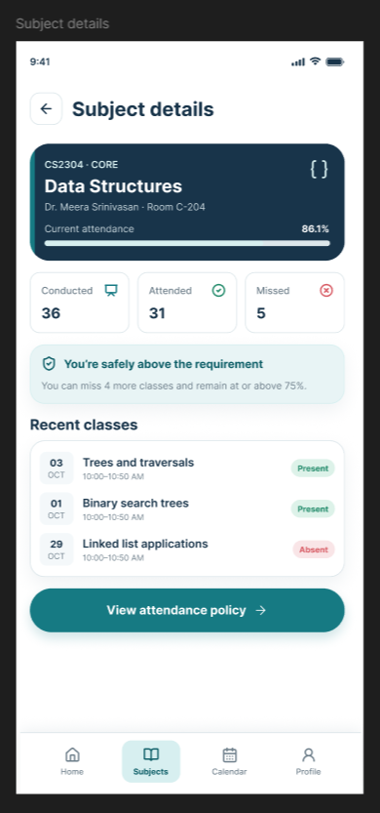

4. Attendance Calendar – Display present, absent, and leave status for different dates.
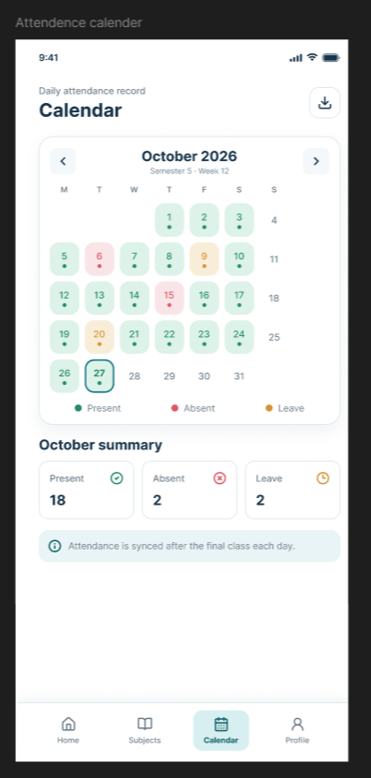

5. Profile Screen – Student photo, name, department, year, and register number.
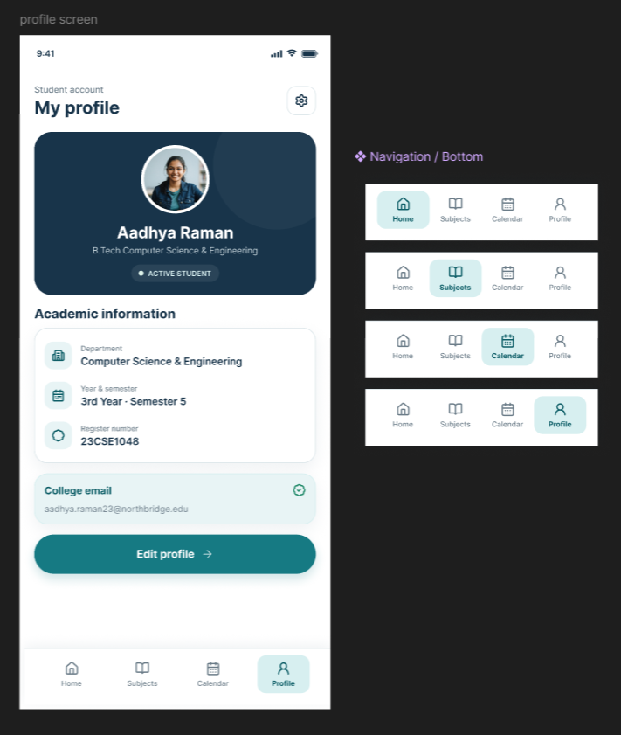
Figma requirements: Create reusable components for buttons and navigation elements, use
Auto Layout, and create a clickable prototype connecting all screens.

3. E-Commerce Clothing App – Product Purchase Interface
Scenario:
An online clothing store wants a mobile application where customers can browse products,
view product details, select sizes, and add products to their shopping cart.
Question:
Using Figma, design the following screens for the clothing shopping application:
1. Home Screen – Search bar, categories, promotional banner, and featured products.
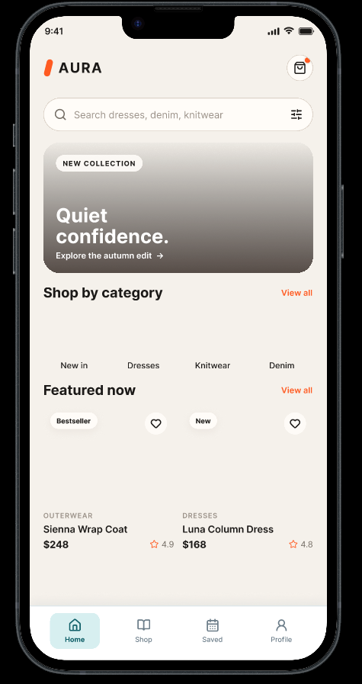
2. Product Listing Screen – Product image, name, price, rating, and filter option.
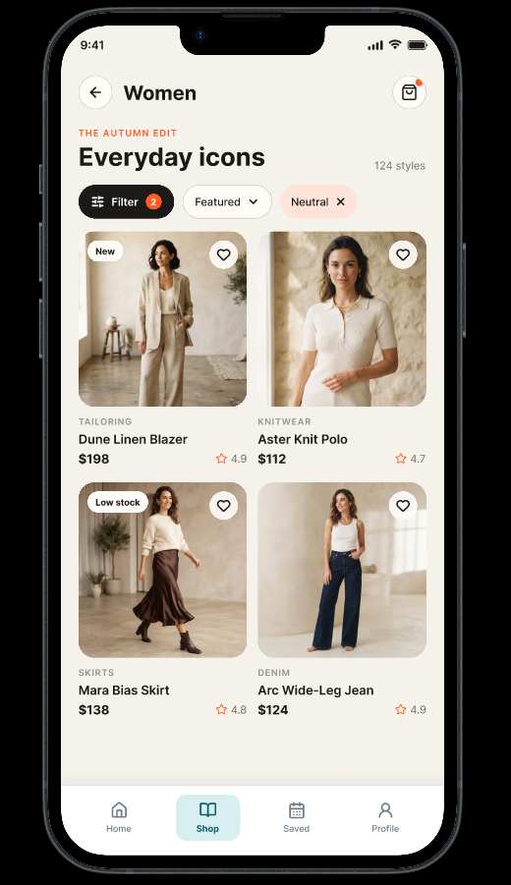

3. Product Details Screen – Large product image, product name, price, description, size
selection, and Add to Cart button.
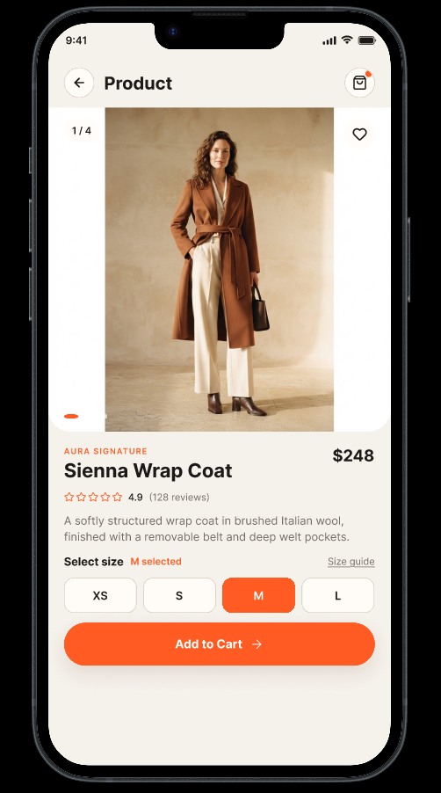

4. Shopping Cart Screen – Selected products, quantity controls, price, and total
amount.
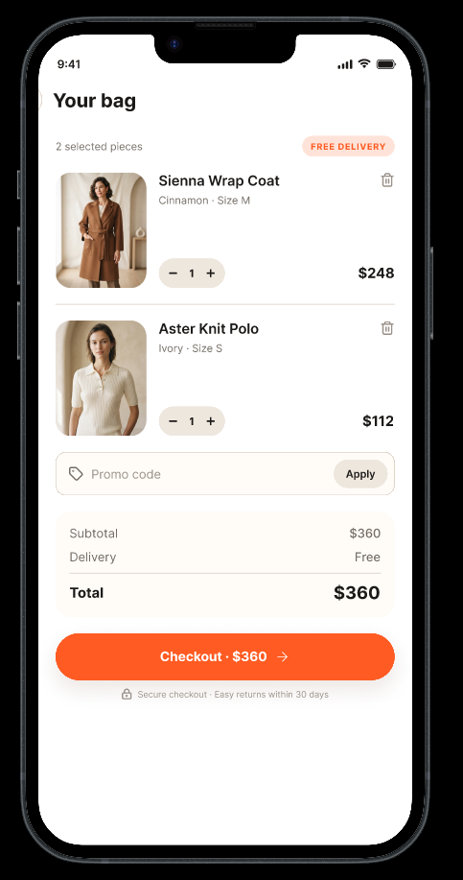

5. Checkout Screen – Delivery address, payment method, total amount, and Place
Order button.
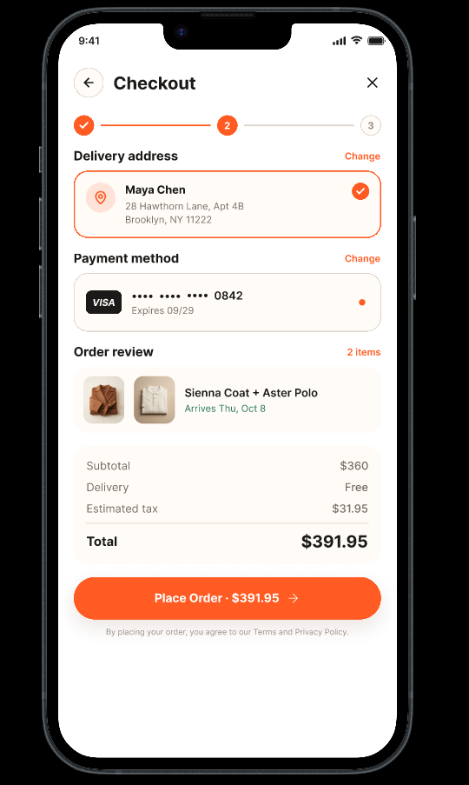
Figma requirements: Use Components, Variants, Auto Layout, icons, and Prototype
navigation. The size-selection buttons should demonstrate different component states.

4. Hospital Appointment Booking System – Healthcare UI
Scenario:
A hospital wants a mobile application that allows patients to search for doctors and book
appointments online.
Question:
Using Figma, design a hospital appointment booking application with:
1. Welcome/Login Screen – Hospital logo, patient login fields, and Login button.
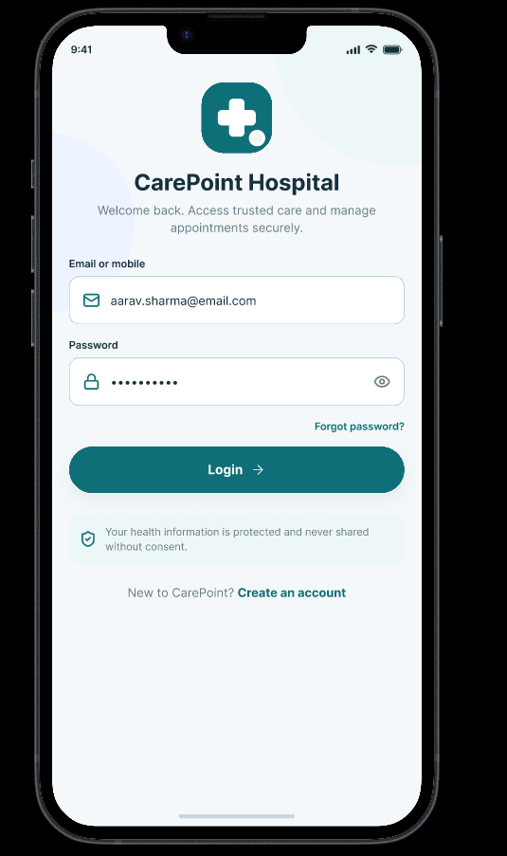
2. Doctor Search Screen – Search bar, medical specialties, doctor cards, and filters.
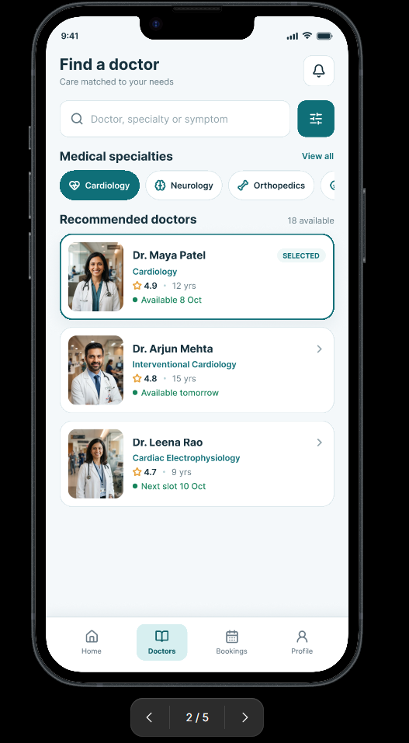
3. Doctor Profile Screen – Doctor photograph, name, specialization, experience,
consultation fee, and available time slots.
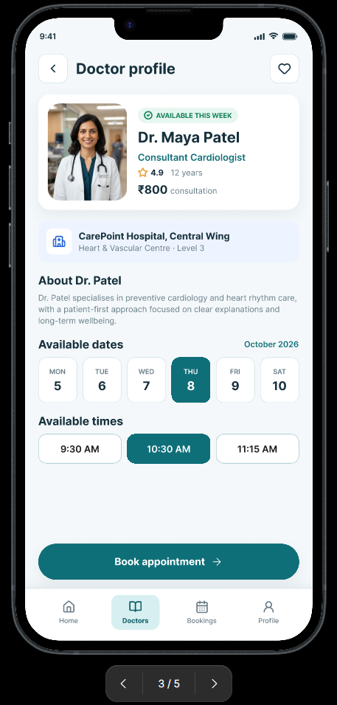
4. Appointment Booking Screen – Selected doctor, date selection, available time slots,
and Book Appointment button.
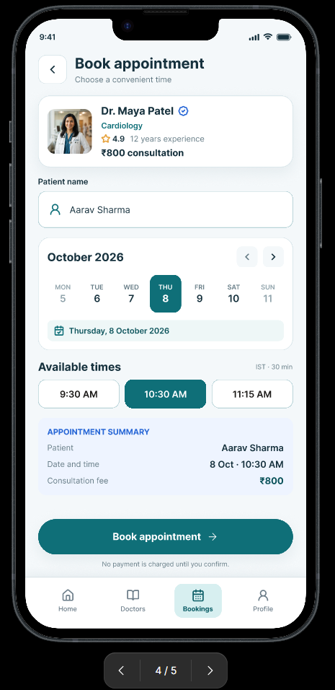
5. Confirmation Screen – Patient name, doctor name, appointment date, time, and
appointment ID.
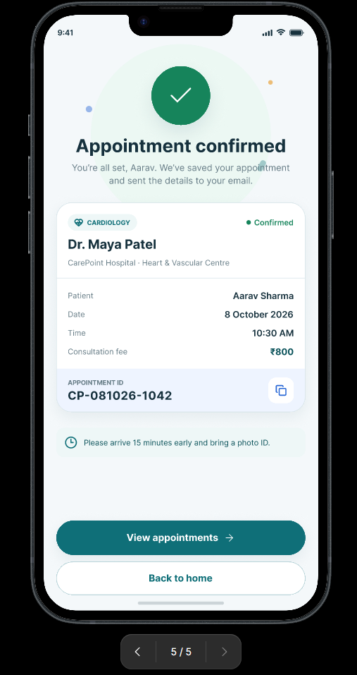
Figma requirements: Use Auto Layout, Components, consistent typography, icons, and
Prototype interactions. The prototype should allow a user to navigate from doctor selection
to appointment confirmation.

5. College Event Registration Website – Responsive UI Design
Scenario:
A college is organizing a technical symposium and needs a website where students can view
event information and register for events.
Question:
Using Figma, design a responsive website for the technical symposium containing:
1. Home Page – Event logo, navigation menu, event title, date, venue, and Register
Now button.
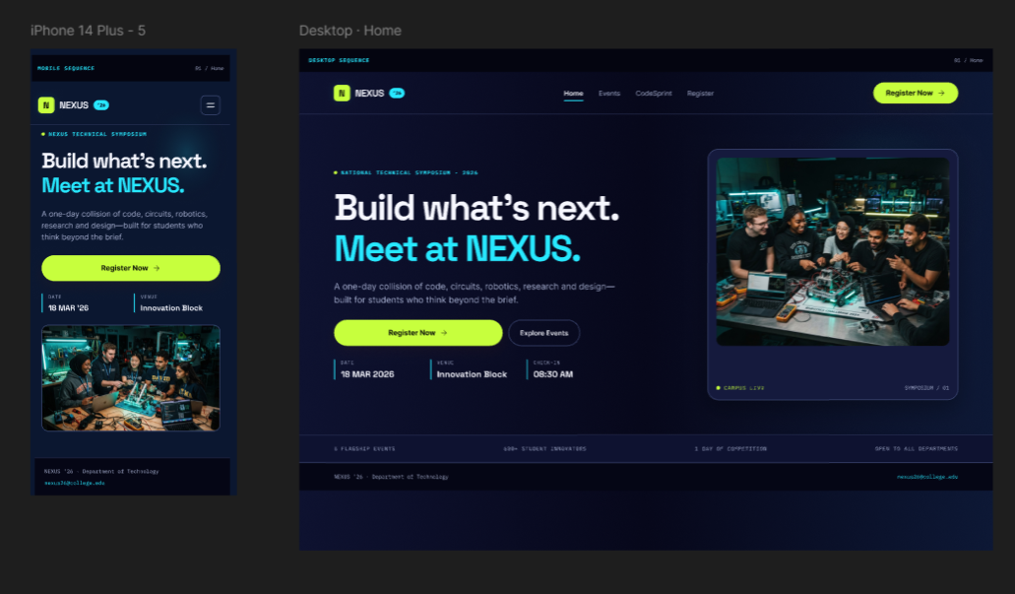2. Events Page – List of technical events with event name, description, date, and
Register button.
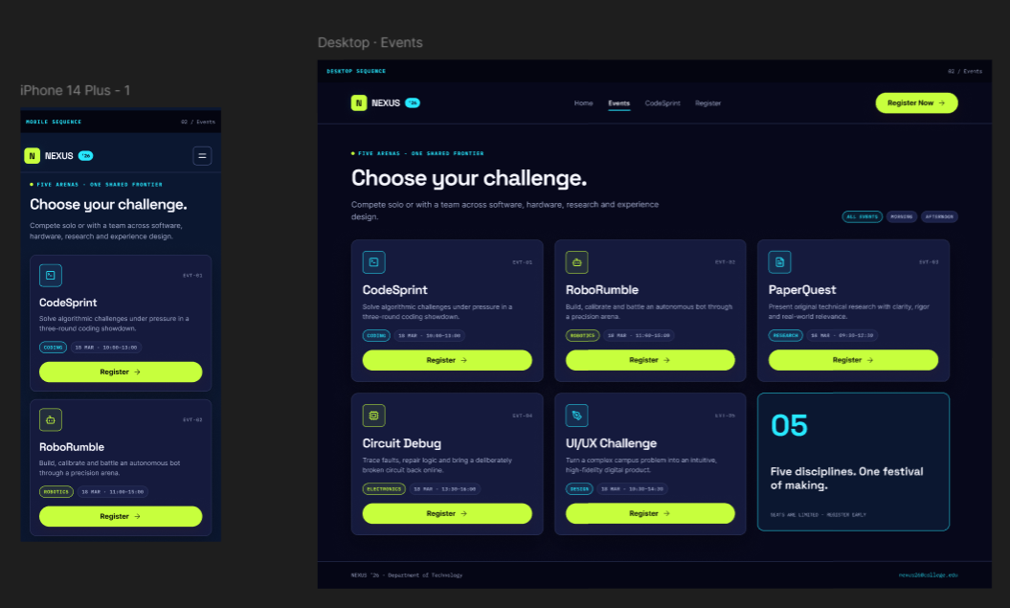3. Event Details Page – Event description, rules, eligibility, schedule, and registration
option.
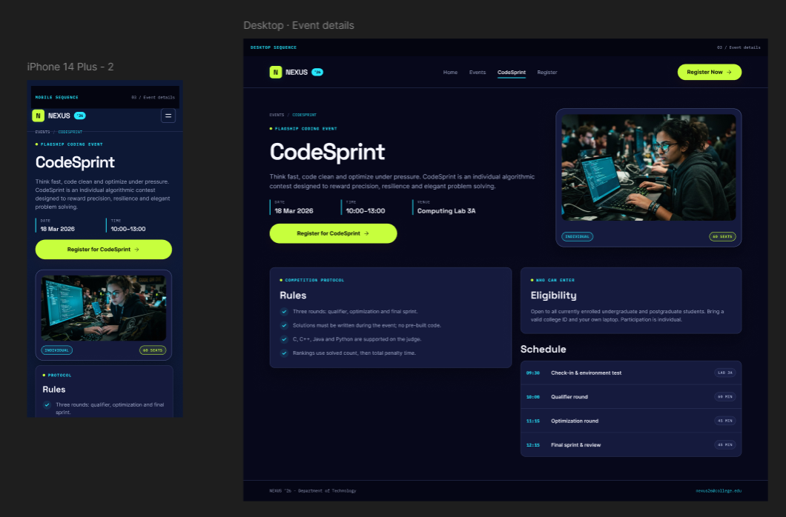4. Registration Page – Student name, email, department, year, selected event, and
Submit button.
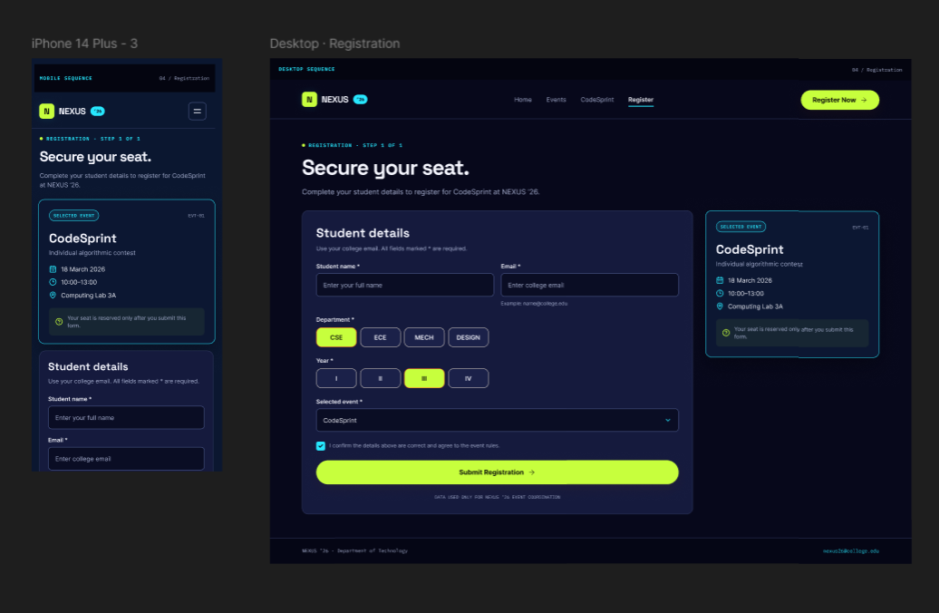
5. Registration Confirmation Page – Registration ID, selected event, date, and
confirmation message.
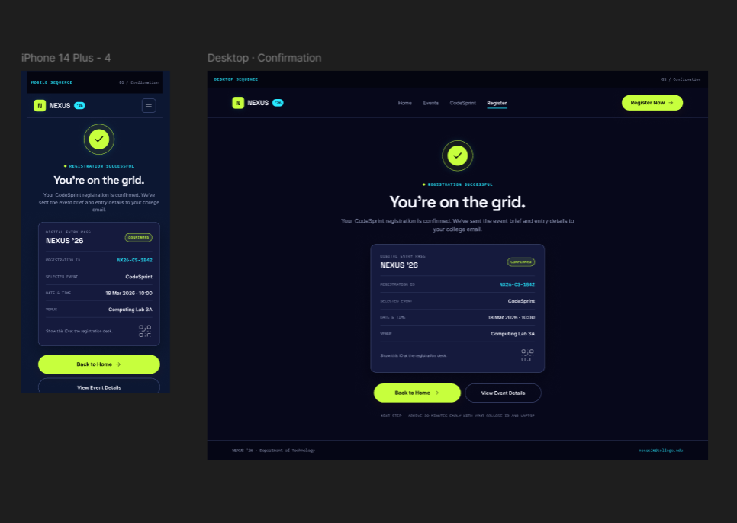
Figma requirements: Create both desktop and mobile layouts using responsive Auto
Layout, Components, grids, and Prototype interactions. Demonstrate navigation from the
Home Page → Events → Event Details → Registration → Confirmation.

